CRM Development Environment Manual

Azure

Contents

Introduction 3

Infrastructure 4

Software 4

Networking 4

Network Diagram 5

Script Operation 5

Deployment 6

Executing the Script 6

How to deploy 6

Reference 7

User Accounts 7

## Introduction

This documents covers the use and technical specifics of the Azure CRM Development Environment. To enable developers to quickly deploy and development environment into Azure a series of scripts have been made up which will automatically deploy the software that is required.

## Infrastructure

The infrastructure is essentially made up of 3 virtual machines, all 3 of these machines are being hosted with Azure within a resource group. The functions of the machines are as follows:

**DC01** – This is the domain controller that will provide the domain accounts that are required by the CRM and SharePoint software

**CRM01** – This hosts two services, firstly the SQL instance that is shared by both CRM and SharePoint and also the CRM software itself.

**SHA01** – This is the host for the SharePoint server software, this is optional.

### Software

The following software is deployed in this environment:

* SQL Server 2016
* CRM Server 2016
* SharePoint 2016
* Server 2012 DC

### Networking

Networking is handled by Azure, however these boxes have been assigned Static IP’s on Azure as follows:

|  |  |
| --- | --- |
| Server | Internal IP |
| DC01 | 10.0.0.4 |
| CRM01 | 10.0.0.5 |
| SHA01 | 10.0.0.6 |

Public IP’s address are assigned dynamically.

### Network Diagram

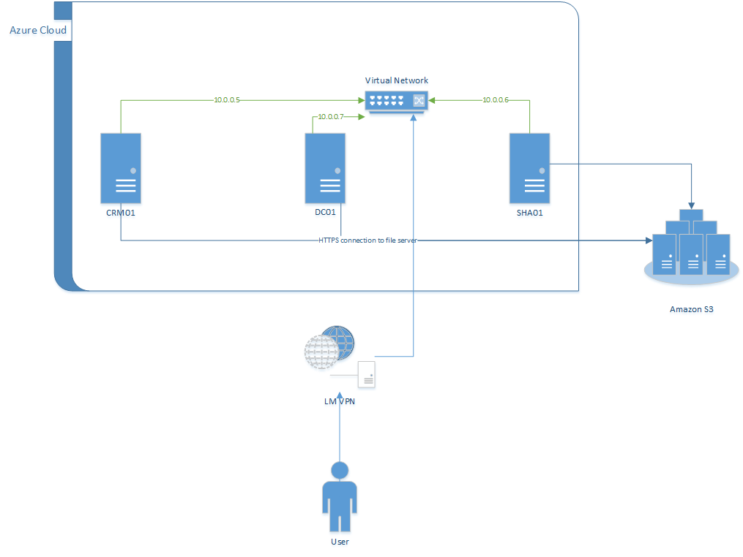

### Script Operation

The script treats software and hardware separately. The infrastructure is deployed using a JSON azure template file which is passed to Azure at the start of the deployment, this creates the VM’s and all the networking that will be required. When the template has finished deploying a Success state will be shown within the Azure console.

The software is then installed using further PowerShell scripts. The scripts are called using the Azure VM agent which downloads the script file and then executes on the machine. There is a script for each software piece that is installed. The scripts are installed in the order they are required, which at a high level is:

1. Install DC Services and promote DC01 to a DC. Then reboot
2. Create the required Services accounts on the DC
3. Join Domain and Install SQL on CRM01 and reboot
4. Install CRM server on CRM01 and reboot
5. (Optional) Join domain and install SharePoint on SHA01 and reboot.

## Deployment

An end user will only require the Install script on their local machine to install the software that is required.

Before starting the script you must ensure that you have an Azure account, the script will prompt you for this.

### Executing the Script

The script makes use of Azure Powershell Cmdlets, these needs to be installed prior to starting the script. The link for the installer and instructions can be found at: https://azure.microsoft.com/en-gb/documentation/articles/powershell-install-configure/

At the start of the script there will be a few inputs that are required:

* Name of resource Group – a new resource group to place the VM’s in will be required. The name must be unique to your Azure Subscription

A unique storage account name is generated by the template itself.

The script should then continue to rollout and deploy the software. Typically the process takes around 2 -3 hours with a breakdown below:

|  |  |
| --- | --- |
| Action | Time taken |
| Deploy Infrastructure | Upto 40 minutes, highly depended on Azure |
| Build DC and promote | 15 minutes |
| Join DC | 10 minutes |
| Install SQL | 35 minutes |
| Install CRM | 25 minutes |
| Install SharePoint | 25 minutes |

### How to deploy

To deploy the software use the following process:

1. Install the required Azure Powershell Cmdlets as described above
2. Place the InstallScript.ps1 on the local drive
3. Within PowerShell execute the script.
4. The script will continue to deploy depending on the settings stated
5. The CRM script will be placed onto the server, you will need to login to only the CRM server to execute this script.
6. Once the CRM script has been executed everything else will have already been deployed.

# Reference

### User Accounts

There are a number of user’s accounts that exists within the environment. The table below describes these:

|  |  |  |
| --- | --- | --- |
| Account Name | Password | Service |
| .\sysadmin | Lockheed.2015 | Local VM System Account |
| CRMDev\sysadmin | Lockheed.2015 | DC Administrator Account |
| CRMDev\CRMService | Lockheed.2015 | CRM |
| CRMDev\CRMSandboxService | Lockheed.2015 | CRM |
| CRMDev\CRMDeploymentService | Lockheed.2015 | CRM |
| CRMDev\CRMAsyncService | Lockheed.2015 | CRM |
| CRMDev\CRMVSSWriterService | Lockheed.2015 | CRM |
| CRMDev\CRMMonitoringService | Lockheed.2015 | CRM |
| CRMDev\SP_SearchService | Lockheed.2015 | SharePoint |
| CRMDev\SP_ProfilesAppPool | Lockheed.2015 | SharePoint |
| CRMDev\SP_PortalAppPool | Lockheed.2015 | SharePoint |
| CRMDev\SP_Services | Lockheed.2015 | SharePoint |
| CRMDev\SP_CacheSuperUser | Lockheed.2015 | SharePoint |
| CRMDev\SP_CacheSuperReader | Lockheed.2015 | SharePoint |